

Pulping Extract

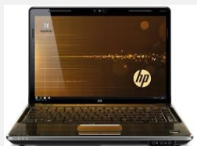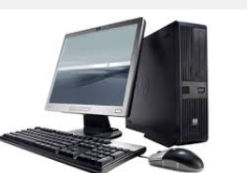

Old Mutual Emerging Markets Customer Service and Technology
Document Ownership
Name
Eg :Name of SOP

Service Owner and Approval
Name | Print Name | Signature and Date
Applicable Service Owner | Stuart Rattray
Senior IT Manager OMEM CST IT | Haamid Kemp

Distribution
Name
OMEM CST IT Services

Version Control
Version | Date | Author/Owner | Reason for Change | Section/Page
1 | 22/12/2023 | Rajinikanth | Created | All

Related Documents
Document Title | Document Owner | Location
Pulping Extract | Rajinikanth

Contents
1. Purpose 4
1.1. Intended Audience 4
1.2. Definition of Service 4
2. Methodology and procedures 4
2.1. Requested Flexi and Conventional Maturity transfers to MAX 4
2.2. EMS requests 4
3. Roles & Responsibilities 8

Purpose
This document is intended to define the step by step procedure to follow when requesting a service: The Procedures, describe the fixed step by step sequence of activities that is followed.

Intended Audience
This policy document is intended to be used by:
- OMEM CST IT Services
- CB&A IT support staff

Definition of Service
This service is to describe all the Closed Book internal transfer processes to the Max product platform in order to assist support staff in analysis in the event of any issues arising due to job failures.

Methodology and procedures
List all the steps with necessary details, including what tools are needed. Cover sequential procedures and decision factors. Address the "what ifs" and the possible interferences or safety considerations

Pulping Extract
As per the below EMS request, we have created a program LUBDISEX which extracts the policy numbers based on date of birth and the extract must include all SMU for flexi and conventional policies.
We will be getting below type of email in our EMS box for Pulping extract.


Source Program:
The program LUBDISEX reads data from flexi contract file and based upon given date of birth it extracts the policy number and client number into output file.

Sample output file:
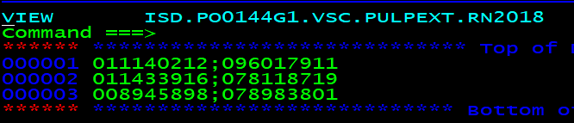
Layout of output file:
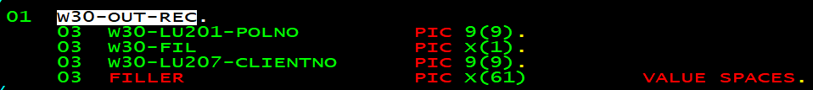
Sample output file:

Roles & Responsibilities
Note:
- Roles & Responsibilities for each step
- Remove greyed out and complete
- Estimated time to complete
Procedure Step no. | Who | Activity | Completion Time
 | Client | Logs a request for Install/Remove Workstation software via Service Now
 | Service Now | Generates email notification for approval/ rejection to Budget Centre Owner
 | Approver | Rejects request
 | Service Now | Automatically moves request to a NO LONGER REQUIRED state
 | Approver | Approves request
 | Service Now | TASK is generated to Service Provider(s) – pending client selection
 | IT Security | If access dependant software has been selected a TASK is sent to IT Security to grant or remove access (e.g MS Lync)
 | SLM | If licensed software has been selected, a TASK is sent to SLM to provide or remove a license key
 | Service Provider | Install / Remove software
 | Service Provider(s) | Complete work and close TASK(S)
 | Service Now | Generates email to client for approval or rejection
 | Client | Approves
 | Service Now | Moves request to a closed/completed state
 | Service Now | Updates configuration item(s) and billing register
 | Client | Rejects
 | Service Now | Generates TASK to CST OMEM IT Aggregator to manage till completion
 | OMEM Aggregator | Ensures completion and closes TASK
 | Service Now | Updates configuration item(s) and billing register

